# VPN (Virtual Private Networks)

 [Refer Here](https://simple.wikipedia.org/wiki/Virtual_private_network) for overview of vpn

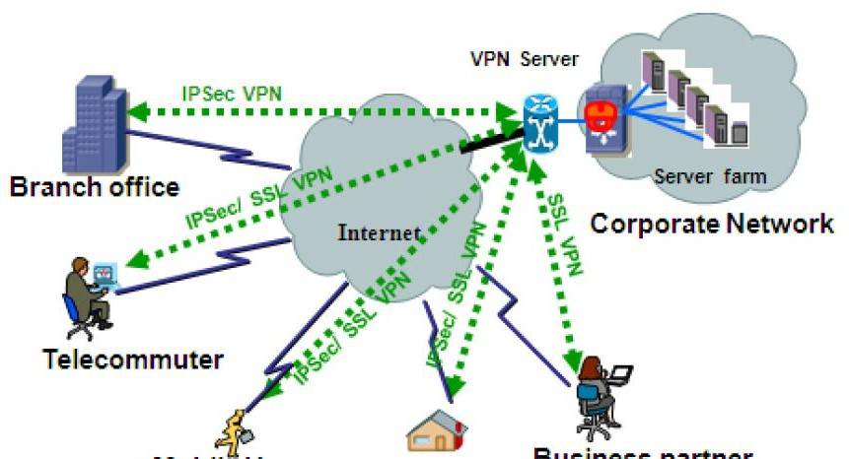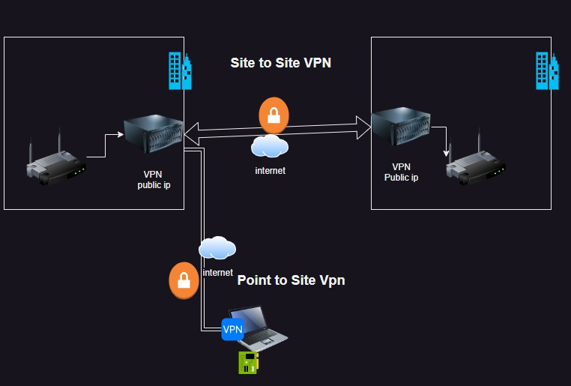

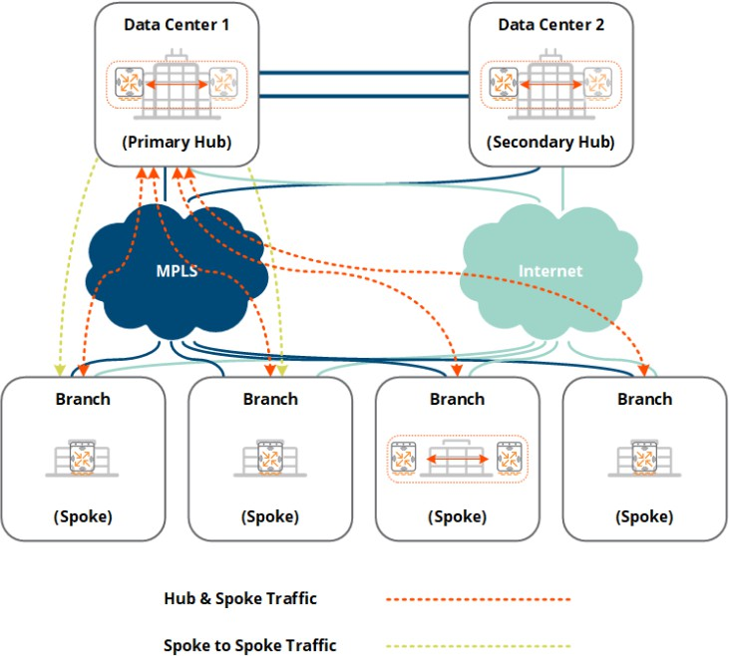 For connective multiple sites, hub-spoke is the popular model

 protocols

 BGP  MPLS

# VPNs in AWS

## Single Site to Single VPC

 We want to establist connectivity between on-premise and vpc

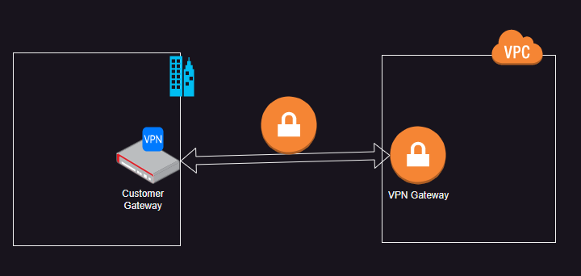 AWS has site-site vpn [Refer Here](https://docs.aws.amazon.com/vpn/latest/s2svpn/VPC_VPN.html)

 To connect multiple vpcs to on-prem we can use Transit Gateway

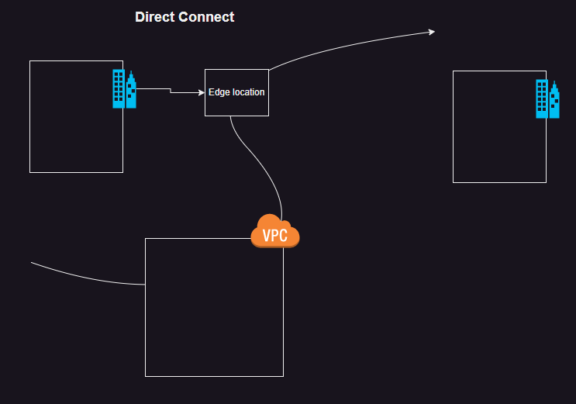 To create a global network with combination of on-premises and vpcs we can create using cloud wan  AWS Direct connect [Refer Here](https://docs.aws.amazon.com/directconnect/latest/UserGuide/Welcome.html) for docs

# VPNS in Azure

## Single Site to Single virtual network

 [Refer Here](https://learn.microsoft.com/en-us/azure/vpn-gateway/tutorial-site-to-site-portal) for official docs

In Azure we can connect multiple virtual networks with the help of hub and spoke [Refer Here](https://learn.microsoft.com/en-us/azure/architecture/networking/architecture/hub-spoke?tabs=cli) Azure Also support virtual WAN [Refer Here](https://learn.microsoft.com/en-us/azure/virtual-wan/virtual-wan-about)

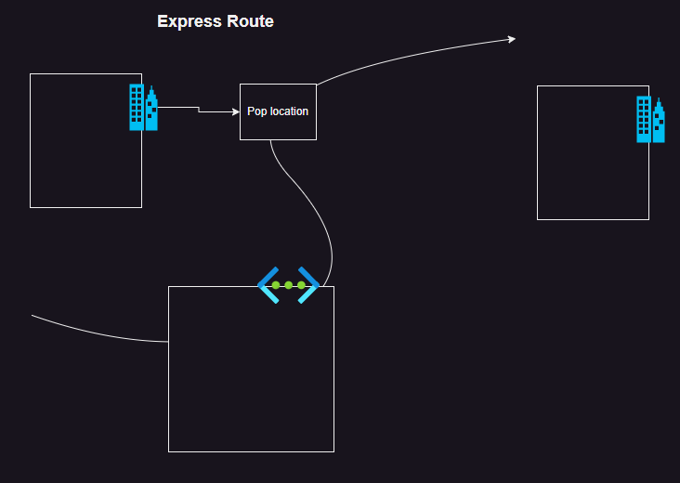Express Route: [Refer Here](https://learn.microsoft.com/en-us/azure/expressroute/expressroute-introduction) for Express Route.